CSA1505-Cloud computing and big data analytics
2-Hotel Room booking
Create a simple cloud software application for Hotel Booking Reservation System using any Cloud Service Provider to demonstrate SaaS include the necessary fields such as search for room,check in,check out etc.
INPUT:
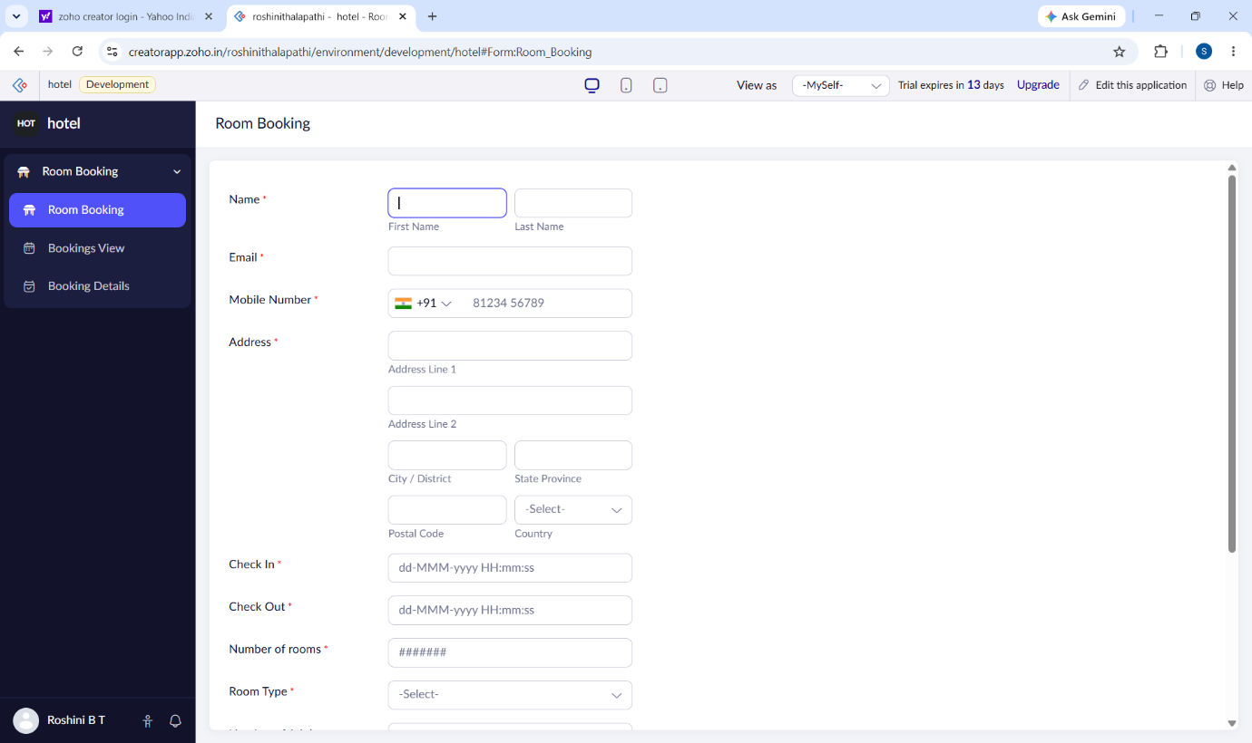

OUTPUT:
